NAME: | Sarcol, Joshua S | DATE: | 09/18/2023

PRACTICE EXERCISE # 4.1

LE4_11 Vowel and Consonant.
Determine whether the letter entered by the user is vowel or consonant. Do not use predefine functions (isAlpha, tolower, toupper, etc.).
Sample/Test Output
Enter a letter: A VOWEL!
==========================================
Enter a letter: a VOWEL!
==========================================
Enter a letter: G CONSONANT!
==========================================
Enter a letter: $ INVALID INPUT!
==========================================
Enter a letter: 5 INVALID INPUT!

Pseudocode: Vowel and Consonant
START
  - INITIALIZE letter as character
  - PRINT “Enter a letter: “
  - READ letter
  - CHECK value of letter
    - IF letter is a vowel
      - PRINT “VOWEL!”
    - ELSE IF letter is consonant
      - PRINT “CONSONANT!”
    - ELSE
      - PRINT “INVALID INPUT!”
    - ENDIF
STOP

Flowchart: Vowel and Consonant
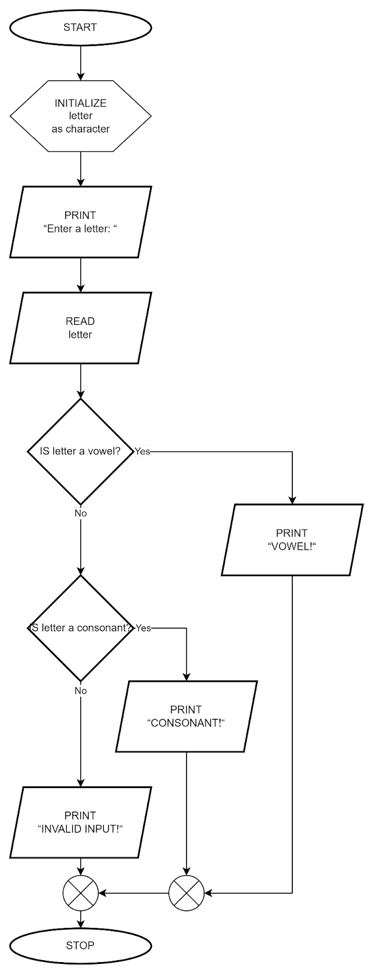

LE4_12 Quadratic Equation.
Compute the real roots of a quadratic equation. The roots can be calculated using the following formulas:
It will prompt the user to enter the constants (a, b, c) and display the roots based on the following rules:

If both a and b are zero, there is no solution
If a is zero, there is only one root (-c/b).
If the discriminate (b2-4ac) is negative, there are no real roots
For all other combinations, there are two roots.

Pseudocode: Quadratic Equation
START
  - INITIALIZE a, b, c, discriminant, x1, x2 as float
  - PRINT “Enter coefficient of x^2 term: ”
  - READ a
  - PRINT “Enter coefficient of x term: ”
  - READ b
  - PRINT “Enter constant term: ”
  - READ c
  - CALCULATE discriminant, discriminant = b*b - 4*a*c
  - SOLVE for the quadratic equation
    - IF a == b and b == 0
      - PRINT “No solutions found.”
    - ELSE IF a == 0
      - CALCULATE x1, x1 = -c / b
      - PRINT “One solution found: x1”
    - ELSE IF discriminant < 0
      - PRINT “No real-numbered solutions found.”
    - ELSE
      - CALCULATE x1, x1 = (-1 * b + sqrt(discriminant)) / 2*a
      - CALCULATE x2, x2 = (-1 * b - sqrt(discriminant)) / 2*a
      - PRINT “Two solutions found: x1, x2”
    - ENDIF
STOP

Flowchart: Quadratic Equation
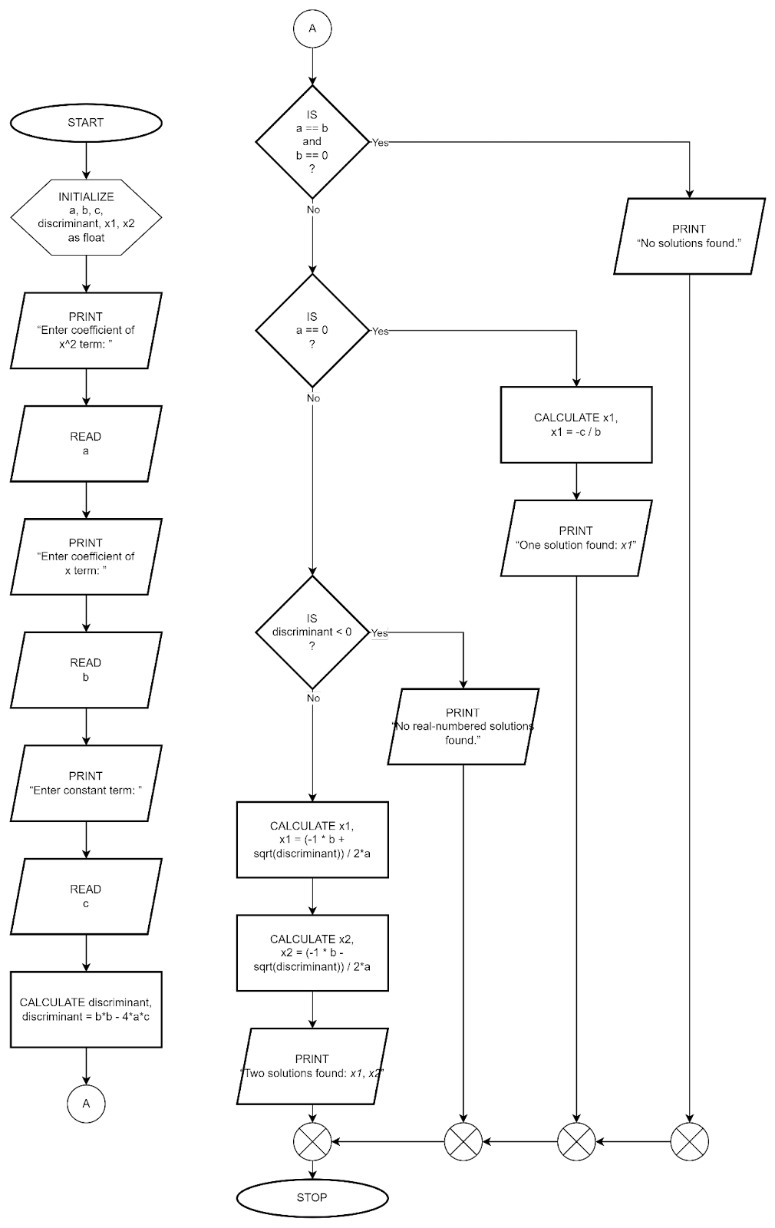

LE4_13 Student’s Final Grade.
Determine a student’s final grade and indicate whether it is passing or failing. The final grade is calculated as the average of four marks (between 0 and 100). Passing grade of 50.
Sample/Test Output
1st Mark : 100 2nd Mark : 85 3rd Mark : 96 4th Mark : 88
FINAL GRADE: 92.25 REMARKS : PASSED
================================================================================
1st Mark : 55 2nd Mark : 70 3rd Mark : 10 4th Mark : 50
FINAL GRADE: 46.25 REMARKS : FAILED
================================================================================
1st Mark : 100 2nd Mark : 120 3rd Mark : 96 4th Mark : 88
INVALID INPUT!

Pseudocode: Student’s Final Grade
START
- INITIALIZE first, second, third, fourth, average as float
- INITIALIZE bound1st, bound2nd, bound3rd, bound4th as integer
- PRINT “1st Mark : ”
- READ first
- CHECK value of first
- IF first <= 0 and first >= 100
      - SET bound1st = 1
- ENDIF
- PRINT “2nd Mark : ”
- READ second
- CHECK value of second
- IF second <= 0 and second >= 100
      - SET bound2nd = 1
- ENDIF
- PRINT “3rd Mark : ”
- READ third
- CHECK value of third
- IF third <= 0 and third >= 100
- SET bound3rd = 1
- ENDIF
- PRINT “4th Mark : ”
- READ fourth
- CHECK value of fourth
- IF fourth <= 0 and fourth >= 100
- SET bound4th = 1
- ENDIF

- CHECK if input values are in range
- IF bound1st + bound2nd + bound3rd + bound4th == 4
- CALCULATE average, average = (first + second + third + fourth) / 4
- PRINT “FINAL GRADE: average”
- CHECK value of average
        - IF average >= 50
          - PRINT “REMARKS : PASSED”
        - ELSE
          - PRINT “REMARKS : FAILED”
        - ENDIF
- ELSE
- PRINT “INVALID INPUT!”
- ENDIF
STOP

Flowchart: Student’s Final Grade
